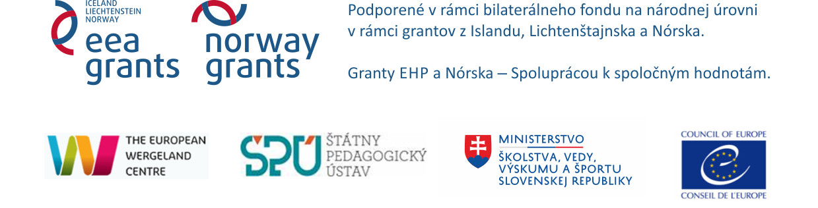

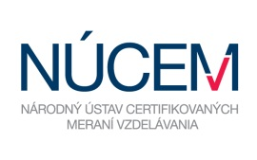
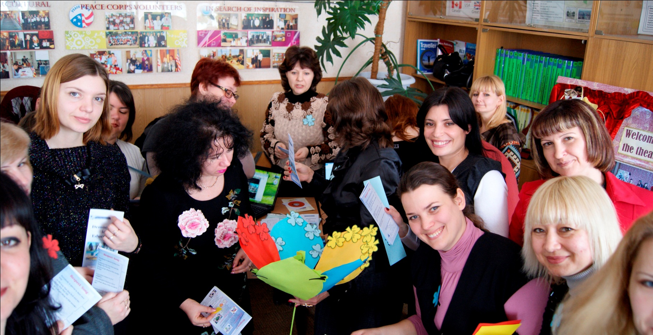
APPLICATION
FORM
BUILDING INCLUSIVE SCHOOL ENVIRONMENTS FOR ALL
Diversity – Recognition – Equity
Slovak and Czech Regional Academy

TBC, Slovak Republic
2 November – 6 November 2016
Organized by the National Institute for Education, Slovak Republic in cooperation with the Council of Europe, the European Wergeland Centre, and partner organizations in the Czech Republic - the National Institute for Education, and in the Slovak Republic - Methodological and Pedagogical Centre, Open-Society Foundation, the National Institute for Certified Educational Measurements.
Academy is organized with the support of the Ministry of Education, Science, Research and Sport, Slovak Republic.

APPLICATION FORM

Complete and send the application form in WORD format by 25 September 2016 to:
Ms Michaela Ujházyová: michaela.ujhazyova@statpedu.sk and CC to
Ms Denisa Ďuranová: denisa.duranova@statpedu.sk

NB: The printed, signed and stamped application form must be posted by 30 September 2016 to:
National Institute for Education
Ms Michaela Ujházyová
Pluhová 8
830 00 Bratislava

Only team leaders of the successful teams will be notified via e-mail by 10 October 2016.

Country of Applicant Team (SR/CZ): |  | Team Leader (choose one of 4 team members)  Name:  Surname:  Tel (with a country code):  E-mail:

Part 1 General Information

INFORMATION ABOUT THE SCHOOL:..

School name:
School head:
Address:

E-mail: Tel (with a country code):

School profile/orientation of the school education programme (100 words max.):

1
INFORMATION ABOUT THE SCHOOL TEAM MEMBERS:
School head or deputy:
Name: Surname:
Position at school:
Years of experience as a school head (deputy) at elementary school:
Teacher of the educational subject:
Years of experience as a teacher:
Qualification(s) and education specialization:
Working language (mark the CEFR level of your language skills): 0 / A1 / A2 / B1 / B2 / C1 / C2
E-mail: Tel (with a country code):

If you attended other trainings on democratic citizenship and/or human rights education, please list them here:

Do you have previous experience in working with education for democratic citizenship and/or human rights education (EDC/HRE)? If so, please describe them shortly:

Teacher of Civics / Ethics:
Name: Surname:
Teacher of educational subject:
Years of experience as a teacher:
Qualification(s) and education specialization:
Working language (mark the CEFR level of your language skills): 0 / A1 / A2 / B1 / B2 / C1 / C2
E-mail: Tel (with a country code):

If you attended other trainings on democratic citizenship and/or human rights education, please list them here:

Do you have previous experience in working with education for democratic citizenship and/or human rights education (EDC/HRE)? If so, please describe them shortly:

2
Teacher of general educational/academic subjects:

Name: Surname:
Teacher of educational subject:
Years of experience as a teacher:
Qualification(s) and education specialization:
Working language (mark the CEFR level of your language skills): 0 / A1 / A2 / B1 / B2 / C1 / C2
E-mail: Tel (with a country code):

If you attended other trainings on democratic citizenship and/or human rights education, please list them here:

Do you have previous experience in working with EDC/HRE? If so, please describe them shortly:

Representative of non-governmental organization:

Name and legal form of the organization:
Address:
E-mail: Tel (with a country code):
Specialization/area of action:

Representative of the organization in the school team:
Name: Surname:
Years of experience in NGO sector:
Qualification:
Working language (mark the CEFR level of your language skills): 0 / A1 / A2 / B1 / B2 / C1 / C2
E-mail: Tel (with a country code):

Please, describe the activities of your organization and your experience in the field of human rights education and education for democratic citizenship:

3
Part 2 Additional Information

Please note that the selection will be based on your answers to the questions below. Discuss your answers in your team. Keep in mind to be short and precise in your answers.

- What motivates you to participate in the Regional Academy? (100 words max.)

- What are your ideas for implementation and dissemination upon returning to your school and local community? (in what part of the school life, in cooperation with organization(s) or schools, time period) (200 words max.)

- Describe specific activity you would like to realize at school upon your return. (200 words max.)

- Describe how you work with diversity in your school environment, e.g. education of children from third countries and/or various minority groups living in the Slovak and Czech Republic, in case you have already gained such experience. (100 words max.)

- In case you have experience in the field, describe an example of good practice in building inclusive school environment for children of foreign citizens and/or of minority background. In case you haven’t had possibility to gain such experience, describe your vision and plans which could be supported by Regional Academy. (200 words max.)

4
Part 3 Responsibilities

The Regional Academy will be held by a team of trainers with international and regional experience, thus the working language of the training is English with interpretation provided when needed. However, all participants should have basic knowledge of the working language and at least two members of the team knowledge at the language level B2 of the CEFR to be able to participate actively in the training.

We are aware of the fact that the Regional Academy is an intensive training programme which includes the development of an EDC / HRE project that will be implemented in our school in the school year 2016-2017. That is why we declare our readiness to participate actively during the whole duration of the educational course, including preparatory tasks in October, the in-person training on 2-6 November 2016, and the project implementation phase which includes evaluation and lasts until June 2017.

Each year, the organizers take photos during the Academy, and some of them are used for promotion purposes (e.g. website, promotion leaflet). We agree that pictures where we feature might be used for promoting the Regional Academy:
Yes: ____ No: ____

I hereby give consent for my personal data included in my application to be processed in accordance with the Act No. 122/2013 Coll. on the Protection of Personal Data by the National Institute for Education for the purposes of the selection process, realization of the educational programme, promotion and information about the Regional Academy 2016 Programme. My consent includes providing the data to third parties for the purposes of the selection process. I am aware that processing my personal information will conform the Act No. 122/2013 Coll. on the Protection of Personal Data as amended, especially §28, which regulates my rights to protect my personal information.
Date: ____________________
Full name of the school head of the elementary school: ____________________
Signature of the school head: ____________________ Stamp of the school:

1. Member of the school team
Full name: ____________________
Signature: ____________________
2. Member of the school team
Full name: ____________________
Signature: ____________________
3. Member of the school team
Full name: ____________________
Signature: ____________________
4. Member of the school team
Full name: ____________________
5
Signature: ____________________

Dôležité dátumy:
Prípravná fáza: október 2016
Regionálna akadémia: 2. – 6. novembra 2016
Nadväzujúce aktivity a projektová implementácia: november 2016 – apríl 2017
Vyhodnotenie: máj – jún 2017
Konečný termín podávania prihlášok: do 10. októbra 2016
Potvrdenie o účasti školského tímu: do 17. októbra 2016

V prípade otázok, kontaktujte e-mailom:
Mgr. Michaelu Ujházyovú, PhD.: michaela.ujhazyova@statpedu.sk
a v kópii PhDr. Denisu Ďuranovú: denisa.duranova@statpedu.sk.

Podporené v rámci bilaterálneho fondu na národnej úrovni v rámci grantov z Islandu, Lichtenštajska a Nórska
vo výške 20.000 eur .
www.eeagrants.org
www.norwaygrants.org

